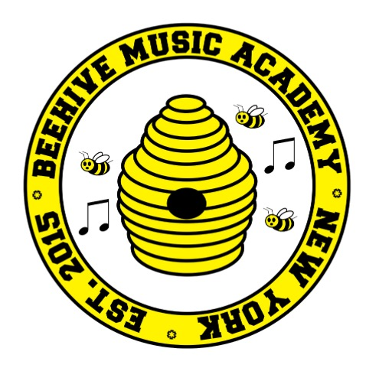
Beehive Music Academy
A Community of Musicians, Educators and Students

FALL/WINTER 2016 SESSION OF PIANO & SONGWRITING SMALL GROUP CLASSES FOR MIDDLE SCHOOL STUDENTS@TAG

Beehive Music Academy is pleased to present our 2016/2017 Piano & Songwriting Classes for Middle School Students at TAG (Grades 6-8) in partnership with the SONYC Y after school program!

We will offer two- 13 Week Sessions for Fall/Winter Session and Winter/Spring Session throughout the school year. Students will learn together in afternoon enrichment that provides students with the opportunity to learn both piano and songwriting with an experienced instructor. Students will have the opportunity to perform and share their compositions!

Piano/Songwriting will take place on Tuesday afternoons. Session 1 dates: 10/18, 10/28, 11/1, 11/8, 11/15, 11/22, 11/29, 12/6, 12/13, 12/20, 1/3, 1/10 and 1/17. Class time: 2:30 pm -3:30 pm.

Registration Deadline: Wednesday October 5th. Payments can be made online through the Beehive Music Academy: 1. Go to www.beehivemusicacademy.com 2. From the menu at top of the home page, select Payments Page 3. Scroll down and click on “pay now” button and follow online payment procedure. The fall/winter fee is $250.00.

Feel free to contact piano parent volunteer, Kathy Powell-Manning at
enrichment@tagscholarspta.org

Thank you and looking forward to helping our young students learn and grow through the positive power of Music!

www.beehivemusicacademy.com

